Operating Systems Principles
Final Exam, Fall 2015
Tuesday, December 15, 2015
Section 1 (3-4:15)
Instructor: Dr. Ghassan Shobaki

Student Name:_______________ Student ID:____________

Question | Points | Score
1 | 30
2 | 15
3 | 20
4 | 15
5 | 20
Total | 100

Question 1: Short Conceptual Questions [30 points]
Choose the right answer. In Questions 1-10 below, there is only one correct answer.

- What is the advantage of using loadable kernel modules compared to the microkernel approach?
- Having a small and manageable primary module that only includes the core functionalities.
- Modules communicate directly without the need for message passing.
- The kernel does not have to be recompiled if a non-core functionality changes.
- The OS is divided into multiple components instead of having a simple monolithic structure.

- What’s the difference between a Zombie process and an Orphan process?
- The parent of a Zombie has terminated without calling wait().
- The parent of an Orphan has terminated without calling wait().
- A Zombie has an entry in the process table, while an Orphan does not.
- Unlike an Orphan, a Zombie still has all of its resources allocated.

- Which of the following is not necessarily performed by the operating system in handling a page fault?
- Issuing a read request to the disk to fetch the missing frame into memory.
- Granting the CPU to a process other than the process that caused the page fault.
- Saving the state of the process that caused the page fault.
- Updating the page table to indicate that the missing frame is now in physical memory.

- Which of the following is true about paging?
- Paging eliminates internal fragmentation but does not eliminate external fragmentation.
- Paging eliminates external fragmentation but does not eliminate internal fragmentation.
- Paging eliminates both external fragmentation and internal fragmentation.
- Paging does not eliminate any kind of fragmentation.

- Which of the following is true about segmentation?
- Segmentation eliminates external fragmentation.
- Segmentation increases external fragmentation relative to contiguous memory allocation.
- Segmentation reduces external fragmentation relative to contiguous memory allocation.
- Segmentation has no effect on external fragmentation.

- What’s the relationship between page size and fragmentation?
- A larger page size decreases external fragmentation.
- A larger page size decreases internal fragmentation.
- A larger page size increases internal fragmentation.
- A larger page size increases external fragmentation.

- Which of the following is not true?
- An array must fit within a single page.
- An array must fit within a single segment.
- Paging divides the memory into equal blocks.
- Segmentation may divide the memory into unequal blocks.

- Which of the following is true about the difference between Rate-Monotonic Scheduling (RM) and Earliest-Deadline-First (EDF) Scheduling?
- RM is preemptive, while EDF is not.
- RM tends to cause more context switching.
- RM uses fixed priorities while EDF dynamically adjusts priorities.
- RM is less likely to cause a process to miss its deadline.

- Priority-based schedulers in modern operating systems minimize the response time for interactive processes by:
- Boosting the priority of a process that does not complete within its time quantum.
- Lowering the priority of a process that does not complete within its time quantum.
- Lowering the priority of a process after it is released from waiting for I/O.
- Boosting the priority of a process after it is released from waiting for I/O.
- a and c.
- b and d.

- Which of the following is true about open-file tables?
- The open-file count is stored in the per-process table.
- A pointer to the last read location is stored in the system-wide table.
- The file location on disk is stored in the system-wide table.
- The file size is stored in the per-process table.
- Access rights are stored in the system-wide table.

In the questions below, circle all that apply. Some questions may have only one correct answer. You will get zero credit for a question if you circle all the options in it.

- Which of the following are true about message synchronization?
- If the sender uses blocking send, the receiver must use blocking receive.
- If the sender uses non-blocking send, the receiver may use blocking receive.
- Using non-blocking send/receive can improve performance if the sender/receiver has some other work to do.
- If we use both blocking send and blocking receive, the solution to the producer-consumer problem becomes trivial.

- Which of the following are true about directory structures?
- A directory structure can always be represented by a tree.
- A directory structure may be represented by a graph but the graph can never have cycles.
- When there are links, the directory structure is a graph not a tree.
- When there are links, the directory structure is necessarily a cyclic graph.

- Which of the following are true about threads?
- Each thread can have its own stack.
- All threads within the same process share global variables.
- All threads within the same process must run on the same core.
- A thread always competes for the CPU with other threads within the same process and can never compete with threads that belong to other processes.

- Which of the following are true about the difference between parallelism and concurrency?
- It is possible to have concurrency without parallelism.
- If the system has a single CPU, we can only have concurrency but cannot have parallelism.
- It is impossible for concurrency to give real speedup.
- Concurrency may give real speedup if CPU computation can be overlapped with I/O.

- Which of the following are true about virtual memory?
- It makes it possible to load more processes into memory, thus increasing parallel programming.
- It allows better memory utilization by keeping only one physical copy of a shared library.
- Only those instructions that the program actually executes are loaded into physical memory.
- A program can be run even if its memory needs exceed the amount of physical memory.

Question 2: CPU Scheduling [15 points]
- Schedule each of the following inputs using the algorithm shown below it. First give the output in the form of a Gantt chart, and then compute the average waiting time. Show your work.

Input 1:
Process CPU Burst
P₁ 5
P₂ 2
P₃ 7
P₄ 3
Apply Round Robin (with a time quantum of 3). Assume that all processes arrive at time 0 but in the order shown in the above table (there are negligibly small differences in arrival times). (6 points)

Input 2:
Process Arrival Time CPU Burst Priority
P₁ 0 7 2
P₂ 2 3 1
P₃ 4 2 3
P₄ 6 4 1
Apply Preemptive Priority Scheduling. Assume that a smaller number indicates higher priority. If a tie ever occurs, break it arbitrarily. (5 points)

(b) A major problem with priority scheduling is starvation.
- Why is priority scheduling more likely than other scheduling algorithms to cause starvation? Describe how starvation happens in priority scheduling. (2 points)

Because lower priority processes may never get the CPU.
This happens if higher priority processes keep arriving.

- Give one good solution that operating systems use to prevent starvation in priority scheduling. Give a brief description of the solution, not just its name. (2 points)
The process will have its priority increased based on its waiting time. The longer a process waits, the more its priority will be increased.
This process is called aging.

Question 3: Deadlocks [20 points]
- Given the following snapshot of a system, answer the following questions using the Banker’s Algorithm:

Allocation Max Available
A B C A B C A B C
P₀ 1 2 1 3 4 7 2 1 3
P₁ 1 1 0 4 4 5
P₂ 2 1 1 3 5 6
P₃ 0 2 2 1 3 4
P₄ 3 0 0 4 2 1

- Show that the system is in a safe state by finding a safe sequence. Show your work.
(5 points)

- If a request from Process P₂ arrives for (1, 0, 1), can this request be granted immediately? Show your work. (5 points)

- Consider the following pseudo-code for implementing safety checking in the Banker’s algorithm.
1 Work = Available
2 for i = 0 to n-1
3 Finish[i] = false
4 done = false
5 finishCount = 0
6 While (! done)
7 found = false
8 for i = 0 to n-1
9 if (Finish[i] == false && Need_{i} ≤ Work)
10 Work = Work + Allocation_{i}
11 Finish[i] = true
12 finishCount++
13 found = true
14 break
15 if (found == false II finishCount == n)
16 done = true
17 if (finishCount == n) print “Safe”
18 else print “Unsafe”

- What does each of the Available vector and the Work vector represent? (2 points)
- How many times will the outer (while) loop get executed if the system is in a safe state? Why?
(1 point)

- If we remove the clause “Finish[i]==false” from the condition of the if statement on Line 9 and only check the condition “Need_{i} ≤ Work”, will that lead to a false positive (printing “Safe” for a system that is actually unsafe) or a false negative (printing “Unsafe” for a system that is actually safe)? Briefly justify your answer. (2 points)

- The above algorithm assumes that all safe sequences are equally good. Suppose that we prefer safe sequences in which processes that are holding more resources appear first. So, if P_{i} is currently holding a larger number of resources than P_{j}, a safe sequence in which P_{i} appears before P_{j} is better than a safe sequence in which P_{j} appears before P_{i}. Modify the above code such that it computes the best safe sequence according to the above definition.
In computing the number of resource held by a process, simply sum the instances of all resource types that are currently held by the process. So, in the snapshot of Part (a), P₀ is holding 4 resources and P₁ is holding 2 resources. Your implementation should not change the algorithm’s asymptotic complexity. An inefficient solution will only get partial credit. (5 points)

Question 4: Memory Management [15 points]
- Consider the following diagram for the paging hardware.

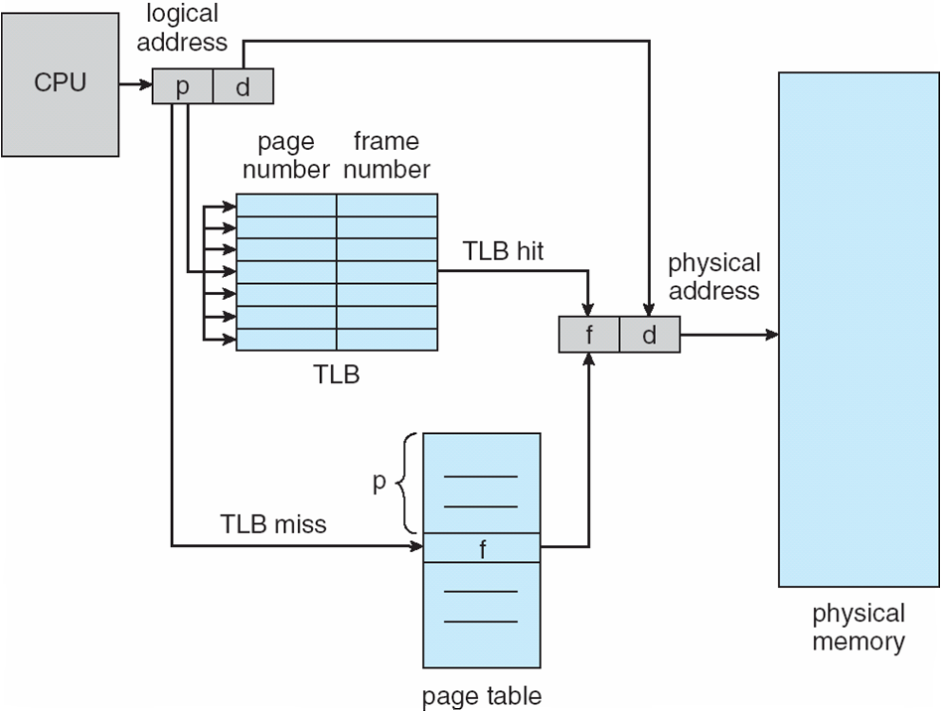

- What is the purpose of the TLB? (2 points)

- Give two factors that improve the TLB’s hit ratio. (2 points)

- Given the following contents for each of the TLB and the page table, compute the physical address for each of the logical addresses below. Assume that the frame (page) size is 4. Given the list of frames that are present in physical memory, indicate for each logical address if that memory access results in a page fault. Also indicate if the access results in a TLB miss.
(6 point)
TLB Page Table Frames in physical memory: 1, 2, 3, 7, 9
Index | Value | Index | Value
3 | 6 | 0 | 5
0 | 5 | 1 | 3
 |  | 2 | 7
 |  | 3 | 6

Logical Address | Physical Address Calculation | TLB miss? | Page Fault?
<0, 2>
<2, 1>
- It was stated in class that page faults do not occur frequently due to locality of reference. For a numerical example, consider the program below with a doubly nested loop:

Code Section A
for (i=0; i<1000; i++) {
Code Section B
for (j=0; j<100; j++)
Code Section C
}
Code Section D

Given the following page accesses (code and data) for each code section,
Code Section A accesses 200 pages
Code Section B accesses 100 pages
Code Section C accesses 6 pages
Code Section D accesses 400 pages

Calculate the percentages shown below. Assume pure demand paging but that the pages of this process fit into physical memory and will not be knocked out of memory by other processes after they have been loaded. Also assume for simplicity that the pages accessed by the different code sections do not overlap with each other. First show the complete formula (don’t ignore anything), and then in doing the calculations, you may neglect insignificant terms.

- The percentage of page accesses that will result in page faults. (3 points)

- The percentage of memory accesses that will result in page faults, assuming that the program accesses 100 memory locations per page. (2 points)

Question 5: Process Synchronization [20 points]
- Consider a multithreaded web server that uses a shared variable to keep track of the number of requests that it services (hit count). The variable is shared among all threads.
- If we don’t use any synchronization constructs, give a specific scenario in which the hit count will have an incorrect value. Explain why the value will be wrong. (3 points)
If the thread is interrupted before it can store the hitCount, and another thread loads the hitCount, it will have the old value. This will cause the hitCount to not show the correct value.

- Describe a solution to this problem using one of the synchronization constructs studied in this course. (2 points)
Protect the increment code in a mutex lock.

- Consider the following solution studied in class for the Readers-Writers Problem:
Writer() {
1 wait(mutex_1);
2 perform_writing ();
3 signal(mutex_1);
}

Reader() {
1 wait(mutex_2);
2 counter++;
3 if (counter == 1)
4 wait(mutex_1);
5 signal(mutex_2);
6 perform_ reading ();

7 wait(mutex_2);
8 counter--;
9 if (counter == 0)
10 signal(mutex_1);
11 signal(mutex_2);
}

- What is the purpose and the initial value of each of the following semaphores/variables? (6 points)

mutex_1:

mutex_2:

counter:

- Suppose that the operating system provides a hardware-supported atomic integer with increment/decrement operations. Will we get a correct solution if we eliminate mutex_2, declare the counter in the above code as an atomic integer and use atomic increment/decrement operations to manipulate it? Briefly explain your answer. (2 points)

- Assuming that the waiting queue for each semaphore is implemented using a First-In-First-Out (FIFO) policy, will it be possible for the writers to starve and will it be possible for the readers to starve in the above solution? Briefly explain your answer. (2 points)

- Assuming that the waiting queue for each semaphore is implemented using a First-In-First-Out (FIFO) policy, modify the above code to ensure that neither readers nor writers will starve. Write comments to explain your solution. (5 points)

